University Of Engineering and Technology, Lahore
Computer Engineering Department

Course Name: Programming Fundamentals | Course Code: CMPE-112L
Assignment Type: Lab tasks | Dated: 20 April 2026
Semester: First | Session: 2026 Spring
Lab/Project/Assignment #: 1 | CLOs to be covered: CLO 2
Lab Title: Local and Global Variables | Teacher Name: Hafiz Muhammad Mubashar
Lab Evaluation:

CLO2 | Apply appropriate programming techniques to create executable programs to solve well defined problems
CLO2 | Level1 | Level2 | Level3 | Level4 | Level5 | Level6
(5)
Total |  |  |  |  |  | /5
Rubrics for Current Lab Evaluation
Scale | Marks | Level | Rubric
Excellent | 5 | L1 | Submitted all lab tasks, BONUS task, have good understanding.
Very Good | 4 | L2 | Submitted the lab tasks but have good understanding
Good | 3 | L3 | Submitted the lab tasks but have weak understanding.
Basic | 2 | L4 | Submitted the lab tasks but have no understanding.
Barely Acceptable | 1 | L5 | Submitted only one lab task.
Not Acceptable | 0 | L6 | Did not attempt
Week 6 LAB
Local and Global Variables
Lab Goals/Objectives:
• To understand the concepts of variable scope (local vs. global variables) in Python functions.
• To analyze how Python resolves variable names using the LEGB (Local, Enclosing, Global, Built-in) rule.
• To identify common scope-related runtime errors, such as the UnboundLocalError.
Equipment Required:

* Computer/Laptop
* Python 3.14
* VS Code or pycharm

Theory:
Scope determines the visibility and lifetime of a variable in a program. Where a variable is defined dictates where it can be accessed or modified.

Lab Work:

Task 1: Local vs. Global Variable Isolation
def f(y):
x = 1
x += 1
x = 5
f(x)
Result:

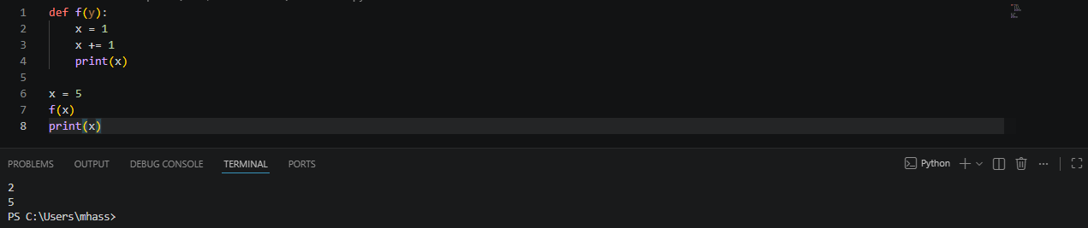

Task 2: Reading Global Variables Within a Function
def g(y):
print(x)
x = 5
g(x)
Result:
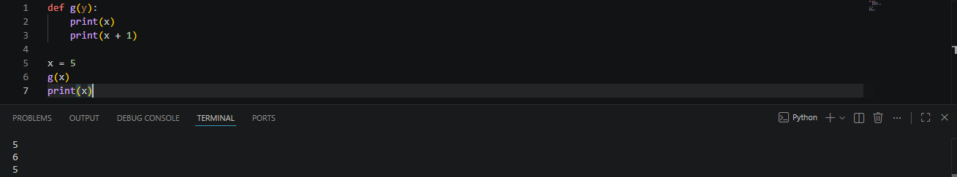

Task 3: UnboundLocalError Trigger (Illegal Global Modification)

def h(x):
x += 1
x = 5
h(x)
Result:
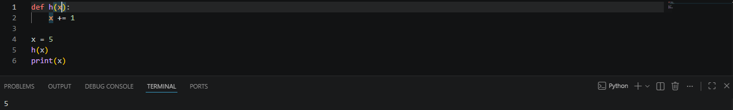

Task 4: Enclosing Scope and Nested Function Execution
def g(x):
def h():
x = 'abc'
h()
return x
Result:

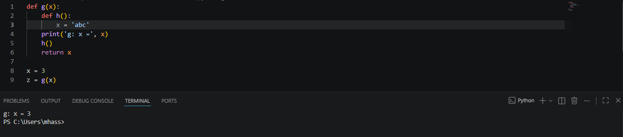

Conclusions:
This lab successfully demonstrates the boundaries of variable scoping rules in Python. We observed that functions isolate their inner computations using local scopes, preventing accidental side effects on global variables. Furthermore, we explored how nested functions look outward to enclosing scopes, and how attempting to modify an outer variable without proper declaration triggers strict runtime scope errors.

